**Newton School Project:**

**Learners have to develop a dashboard to support the answers to the following questions and suggestions for places for newer restaurants.**

**Objective Questions**:

1. What is the total no. of tables present in the data?

* 2

1. What is the total no. of attributes present in the data?

* 20+2

1. How many categorical columns are there in the data? [Search about categorical and continuous data, and try to answer this question]

* Categorical Column (15): Country Code, Country, city, Price Range, Delivery, has delivery now, locality, Localityverbose, cuisines_updated, currency, switch to order menu, Restaurant name, restaurant id, address, currency.
* non-categorical columns (5): votes, average cost of two, date, longitude, latitude.

1. The data consists of some inconsistent and missing values so ensure that the data used for further analysis is cleaned.

* I handled the missing value in the Cuisine column by creating a new column, Cuisine Updated, where I replaced the missing value with "Missing." Then, I replaced the original Cuisine column with this updated version for better data management.
* A screenshot of a computer

  Description automatically generated

1. Using the LookUp functions, fill up the countries in the original data using the country code.

* =VLOOKUP(C2,'country description'!$A$1:$B$16,2,0)

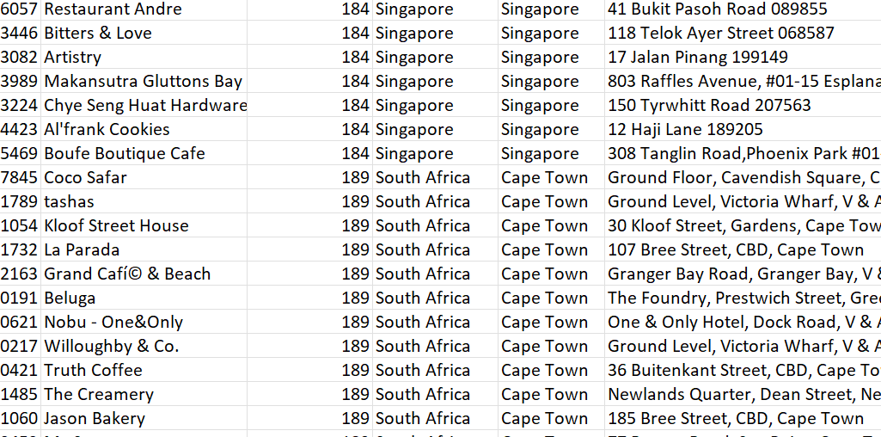

1. Create a table to represent the number of restaurants opened in each country.

1. Also, the management wants to look at the number of restaurants opened each year, so provide them with something here.

1. What is the total number of restaurants in India in the price range of 4?

* I have used the Pivot table with countries in row and filter only for india, count of restraint in values and price range in filter, which gave me the value: 388

1. What is the average number of voters for the restaurants in each country according to the data?

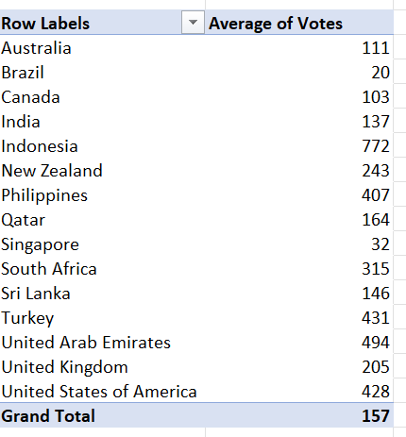

1. Calculate the average rating for all the restaurants that have price_range < 4 and provide online delivery. Use only the “IF” function, Logical Operators, and Aggregation functions to solve this problem. **[Note: Don’t use Conditional aggregation in this question.]**

=AVERAGE(IF(('Raw Data'!Q:Q<4)*('Raw Data'!N:N="Yes"),'Raw Data'!V:V))

1. Using Conditional formatting highlight the rows of restaurants that are located in the countries or cities that you’ve suggested to the management for opening new restaurants.

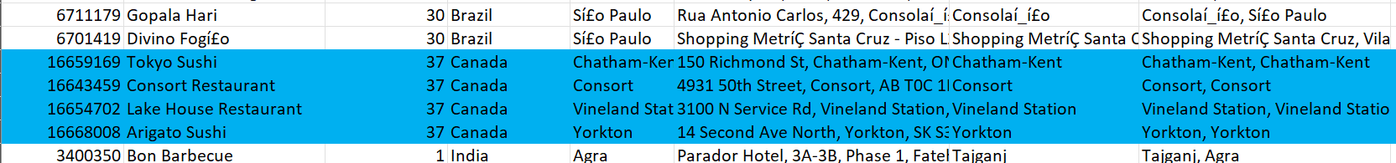

1. Create a new customized price column that consists of the abbreviation/symbol of the currency along with the Average_cost_for_two value. [Use string operations to do this task]

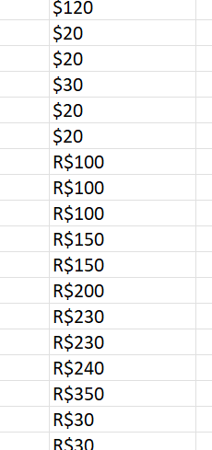

=MID(L2,FIND("(",L2)+1,LEN(L2)-FIND("(",L2)-1) & S2

1. How can you create an array formula in Excel or Google Sheets to count the number of restaurants listed that do not offer online delivery, are in the lowest price range, and have an average cost for two people less than or equal to 250 Indian Rupees?

=COUNTIFS('Raw Data'!N:N, "No",'Raw Data'!Q:Q,"1",'Raw Data'!T:T,"<=250")

1694

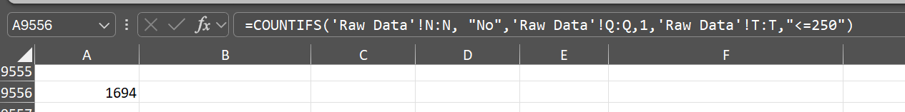

**Subjective Question:**

1. Suggest a few countries where the team can open newer restaurants with lesser competition. Which visualization/technique will you use here to justify the suggestions?

* To approach this problem, I have created a pivot table which shows count of restaurants in countries from there I have shortlisted 4 countries which have least number of restaurants.
* I have done further analysis for these 4 countries where I have checked average rating and average price of 2 customer. Below I have shown both the graphs.
* Apart from these 3 parameters, I have also checked city wise competition which shows that Canada has the least city wise competition in which 4 cities in Canada have single restaurants whereas Qatar Singapore and Sri Lanka have 20 restaurants in a city this means opening a opening a restaurant in this country he will be very competitive as compared to Canada.

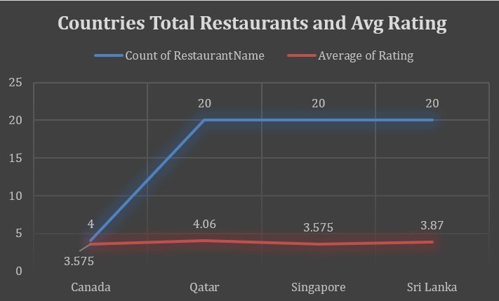

* Canada has the least competition based on the count of restaurants, Apart from Canada, there are other option available like Qatar, Singapore, Sri-Lanka. If we consider Rating also Then Canada ranking lowest in the selected four countries, which means there is a scope of improvement.

* A pair of customer spends around an average of 3K INR in Canada which is not the lowest.

* City-wise competition is also very less in Canada.

1. Come up with the names of States and cities in the suggested countries suitable for opening restaurants.

* To approach this problem, I have created a pivot which contains city wise analysis of Canada which includes primarily count of restaurants in a city and average rating of restaurant in a city.

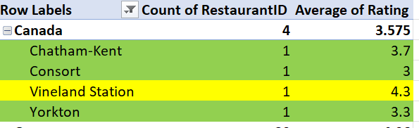

* These cities in Canada will be a good fit for opening new restaurants, because they have only one restaurant in each city, with rating from average to low, high cost of food and no delivery option.

* Cities like Vineland station has a rating of 4.3 which shows that people are liking restaurant in this city which means if we open a new restaurant in this city the customer acquisition cost will be very high on the other hand if we open a new restaurant in a city like concert or Yorkton where the rating is below 3.5 the customer acquisition cost will be very low because these rating shows us that people are not satisfied with the existing services.

1. According to the countries you suggested, what is the current quality regarding ratings for restaurants that are open there?

* In the previous questions we have shortlisted few countries based on the various parameters. And those countries were Canada Qatar Singapore and Sri Lanka.
* Now the above line graph shows average rating of restaurants in these countries which shows that Canada and Singapore has least ratings among these 4 countries which is around 3.5.
* This implies that the people in these countries are not satisfied with the existing services of restaurants. Further we did restaurant wise rating analysis in each of these 4 countries.
* For this I have created a pivot table where I have filtered out these 4 countries with their average rating.

* The above 4 bar graph shows the rating of each restaurant in the shortlisted for countries. For these graphs I have used 4 pivot tables each pivot table filters a single country with all the restaurant names and their rating. And I have used these pivot tables to create all the above graphs.

1. Also, what is the current expenditure on food in the suggested countries, so we can keep our financial expenditure in control?

* For this I have created a pivot table which shows average cost of 2 person in the shortlisted countries.

* The above chart shows that the average cost for two person is lowest in Sri Lanka and highest in Singapore. But Canada and Qatar lie in the middle.
* Low cost shows that people are not much willing to pay so to make profit margin will be difficult. And high cost will not attract much customers. Canada lies in the middle which shows that there are decent numbers of customers who are willing to pay and cost is not so high so if service is improved that price range can attract much more customers.
* This is another factor which strengthen the choice of Canada to open new restaurant. The numbers used in this analysis has a common unit which is Indian Rs.

1. Come up with the names of restaurants from the recommended states that are our biggest competitors and also those that are rated in the lower brackets, i.e. 1-2 or 2-3.  
   Competitor:

* This I have created a pivot table which contains country wise restaurant names and their ratings. Then I have applied filters on ratings to find out which restaurant have rating greater than 4 (potential tough competitors) and which restaurants have rating less then 3 (restaurant with low customer satisfaction level)
* High Rated (Rating > =4)

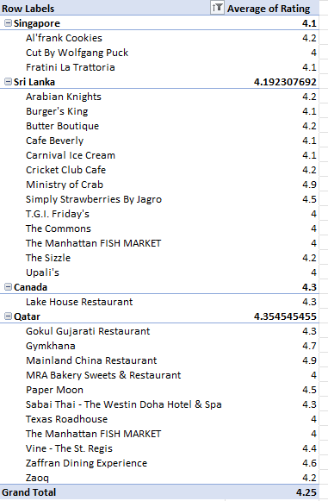

* Low rated: (Rating <=3)

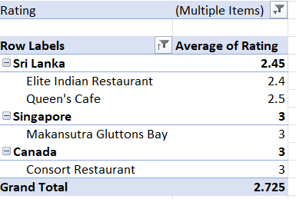

1. Which cuisines should we focus on in the newer restaurants to get better feedback? Does the choice of cuisines affect the restaurant ratings?

* To analyse the various cuisines I have check the cuisine on 3 parameters which are average cost average rating and average votes. On the basis of these 3 parameter I have created 8 categories which can give insights before opening a new restaurant.
* Although it is difficult to name these 8 categories tough competition or less competition because it also depends on the budget of the new restaurant if they want to be a high end restaurant or if they want to server middle class customer or they just want to act like as an QSR. Because of this reason I have not given them any labels of tough competition although these 8 categories provides useful insights.
* For example new restaurant wants to be a high end restaurant then it has to just check the votes and the test satisfactory level (Rating). Because votes tell us the footfall in a restaurant for that particular cuisine. And rating tells us if people are satisfied with the existing cuisines or not.
* I have taken average point of each parameter a deciding factor. Like if the average cost of 2 person for a cuisine is greater than the country average cost of 2 person for a cuisine then that cuisine is termed as expensive otherwise it is cheap.
* Likewise, if rating of a cuisine is greater than average country rating of a cuisine then the cuisine is satisfactory otherwise its taste is unsatisfactory
* similarly for votes if the average vote for a cuisine is greater than country average of votes then this employs that there is a demand for that cuisine otherwise the demand for cuisine is less.
* Using these 3 logics I have created a pivot table and used conditional formatting since each country has its different averages, so I have to apply the conditional formula for each country differently.
* Below is the sample of the pivot chart which shows the conditional formatting also and the different weight categories that I have created.

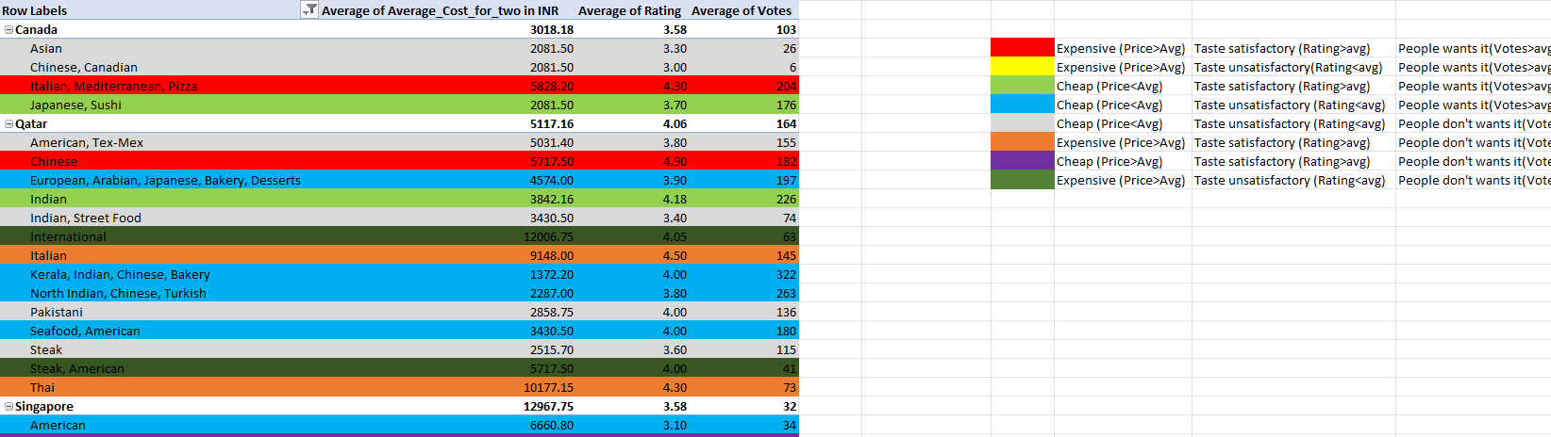

1. According to our current data, should we go for online delivery and table booking? Does that affect the customer’s ratings?

* I have created a pivot table and used table booking, online delivery, average rating and average votes parameter for our shortlisted countries.

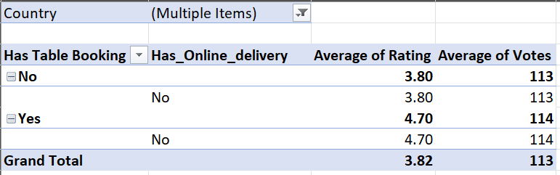

* The above finish chart choose that the shortlisted countries do not have any delivery services. So we cannot actually predict what will be the effect of online delivery but from this table we can see that table booking surely has a positive impact on rating that too when votes for restaurant with table booking and restaurant without table booking are equal. That means restaurant with table booking facility helps in increment of the rating.
* To find the relation of online delivery with the rating we might have to consider the data for all the countries this is only for the delivery options.

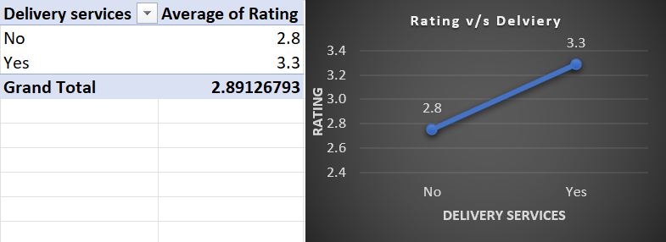

* The above pivot chart and line graph shows that online delivery does help in increasing the rating.

1. Should the team keep the rate of cuisines higher? Will that affect the feedback? According to our data are the rates of cuisines and ratings, correlated?

* To check if there is any correlation between the price and writing I have used a correlation function which gives us the value of 0.344. This implies that there is a positive correlation between the price and rating Which means increment in the price will increase the rating although the increment won't be proportionate to the price that means doubling the price doesn't necessarily mean that it will double the rating but surely it will increase their rating.
* To show it graphically have also used a pivot table with rating and average price as the parameters and using this pivot table I have develop the line graph which shows that cuisines which have higher rating between 3.5 to 4.5 are on the higher end of the price, cuisines which have rating below 3 add very cheap and cuisines which have rating greater than 4.5 are moderately expensive. This shows that even the high end restaurants does not mean the people's demand.
* The team should keep the price moderately expensive because the data shows very cheap menu has very low rating and expensive menu have moderate rating but moderately expensive menu have very high ratings.

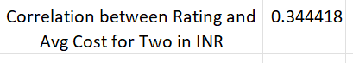

=CORREL(D3:D23,E3:E23)

1. What is the distribution of the number of restaurants of different price ranges in all the countries?

* To find the distribution of number of restaurants based on the price range for each country I have used pivot table where I have put the country in row field price range in column field and count of restaurant names in values field. And the below shown pivot chart gives us the distribution of number of restaurants based on price range for each country.

1. Explain your approach in brief for suggesting countries/cities in order to open new restaurants, if the objective and subjective questions would have not been given to assist you. **[you have to give bullet pointers in order to answer this question]**
   * **Number of Restaurants in the City**  
     A higher number of restaurants increases competition, making it harder to stand out. Fewer restaurants provide an opportunity to capture a larger customer base and dominate the market.
   * **Optimized Average Price**  
     Prices should not be too low, as this may reduce profitability. Instead, they should be set to offer good-quality food while ensuring sustainable profit margins. Striking this balance attracts both customers and long-term success.
   * **Minimum Number of Restaurants with Good Ratings**  
     A low number of highly-rated restaurants indicates customer dissatisfaction with existing services, creating opportunities for new entrants to meet unmet expectations and gain a competitive edge.
   * **Location**  
     The location of the restaurant is crucial. A nice and quiet environment ensures an enjoyable dining experience. At the same time, accessibility and proximity to target customers also play a significant role in success.
   * **Adequate Power and Water Supply**  
     Reliable infrastructure, such as sufficient power and water, is essential for uninterrupted restaurant operations, maintaining food quality, and ensuring a pleasant dining experience for customers.
   * **Variety in the Menu**  
     Offering a diverse menu appeals to a broader audience by catering to different tastes, dietary preferences, and cultural backgrounds, which can help attract more customers and increase footfall.
   * **Delivery Service**  
     A delivery option is essential in modern times, meeting the increasing demand for convenience. While it may incur extra charges for customers, it can significantly expand the restaurant's reach and improve overall ratings and customer satisfaction.

**The dashboard must consist of Year-wise and country slicers.**

